**LAB-3**

**Understanding and Implementations of Basic Gates**

**Equipment:**

Explorer Board

**Software:**

Circuit Maker, Waveforms

**Components:**

IC Type 7408 QUAD two input AND gate

IC Type 7432 Two input OR gate

**Description:**

The Digital Systems should be able to perform operations on the binary number. The simplest operations that come to mind are the arithmetic operations like add and subtract. As the logic gates operate on binary values therefore these function tables describes the relationship between the input and output in terms of binary values.

**Objectives:**

* To understand working of gates
* To Implement gates on explorer board
* To Validate the above implementation using Circuit Maker

**Task 1: The task contains 5 parts.**

1. Consider the given circuitfor part 1.

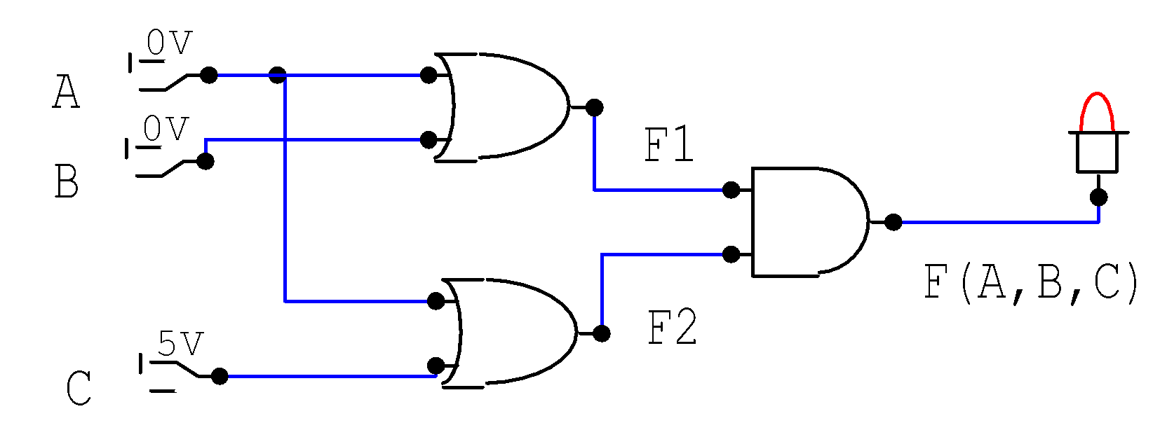

1. Create and fill the table for F1.

|  |  |  |
| --- | --- | --- |
| **Switch 1** | **Switch 2** | **Output** |
| 0 | 0 | 0 |
| 0 | 1 | 1 |
| 1 | 0 | 1 |
| 1 | 1 | 1 |

1. Write the operation that is performed by circuit to generate F1.

**F1=A+B**

1. Implement the above gate on circuit Maker and verify your results.

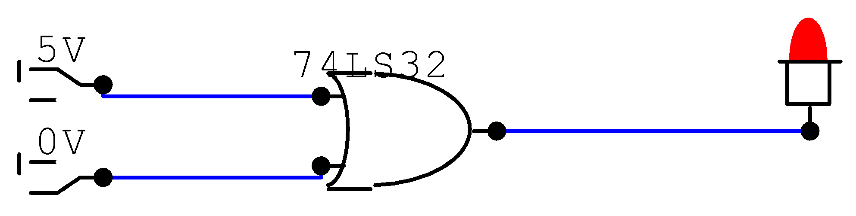

1. Do the followings;
2. Create and fill the table for F2



|  |  |  |
| --- | --- | --- |
| **Switch 1** | **Switch 2** | **Output** |
| 0 | 0 | 0 |
| 0 | 1 | 1 |
| 1 | 0 | 1 |
| 1 | 1 | 1 |

1. Write the operation that is performed by circuit to generate F2

**F2=A+B**

1. Implement the above gate on circuit Maker and verify your result.

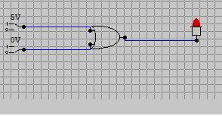

**Result: When Both Switch Turn off LED light will not turn on.**

1. Consider F1 and F2 as input and F as output
2. Create and fill the table for F
3. 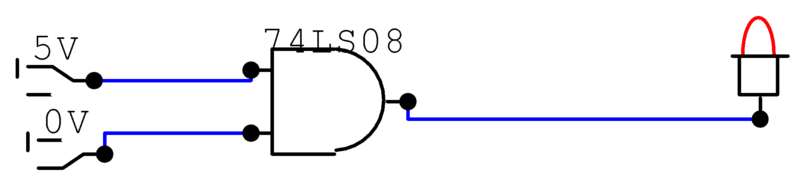

|  |  |  |
| --- | --- | --- |
| **Switch 1** | **Switch 2** | **Output** |
| **0** | **0** | **1** |
| **0** | **1** | **0** |
| **1** | **0** | **0** |
| **1** | **1** | **0** |

1. Write the operation that is performed by circuit to generate F

**F=(A+B).(A+C)**

1. Implement the above gate on circuit Maker and verify your results

**Result:**

1. Consider A, B and C as inputs and F as output
2. Create and fill the table for output F

|  |  |  |  |
| --- | --- | --- | --- |
| **A** | **B** | **C** | **F** |
| **0** | **0** | **0** | **0** |
| **0** | **0** | **1** | **0** |
| **0** | **1** | **0** | **0** |
| **0** | **1** | **1** | **1** |
| **1** | **0** | **0** | **0** |
| **1** | **0** | **1** | **1** |
| **1** | **1** | **0** | **0** |
| **1** | **1** | **1** | **1** |

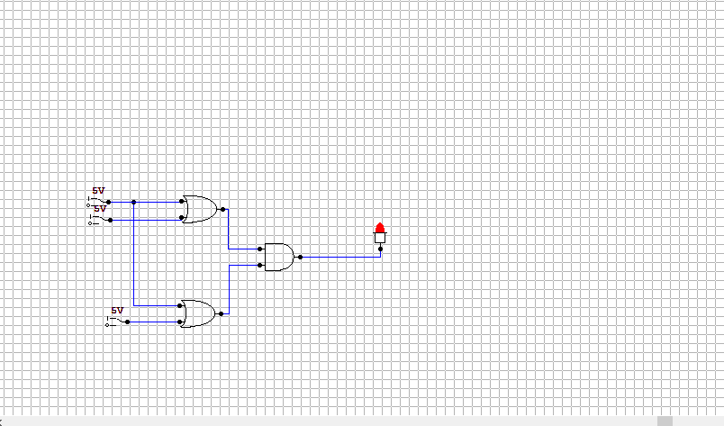

1. Write the operation that is performed by circuit to generate F
2. **F=(A+B).(A+C)**
3. Implement the above gate on circuit Maker and verify your results

**Result:**

The operation performed on inputs to get output F is also known as Boolean Expression or Boolean Equation (as taught in class lecture).

1. Write the Boolean expression for F

**F=(A+B). (A+C)**

1. Write the simplified Boolean expression for F

**A+B.C**

1. Implement both the expressions (simplified and without simplification) in circuit Maker with same inputs (only three common inputs A, B and C) and verify your results

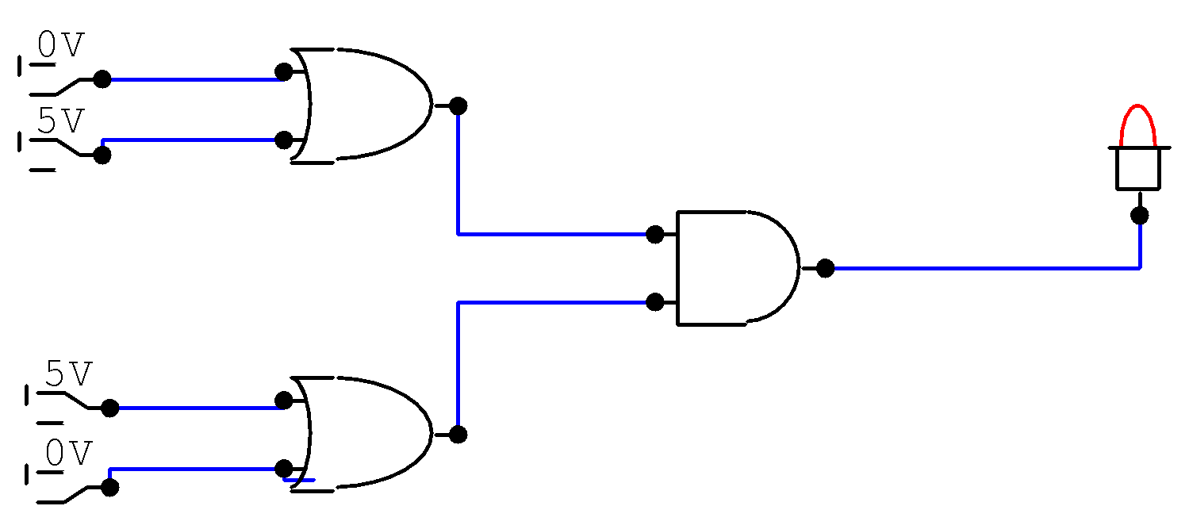

1. Implement the both circuits (simplified and extended) on Explorer Board and verify on Digital Waveform.

**Done**

**Task 2: The task contains 3 parts.**

**Part. 1** Consider the given circuitfor part 1.

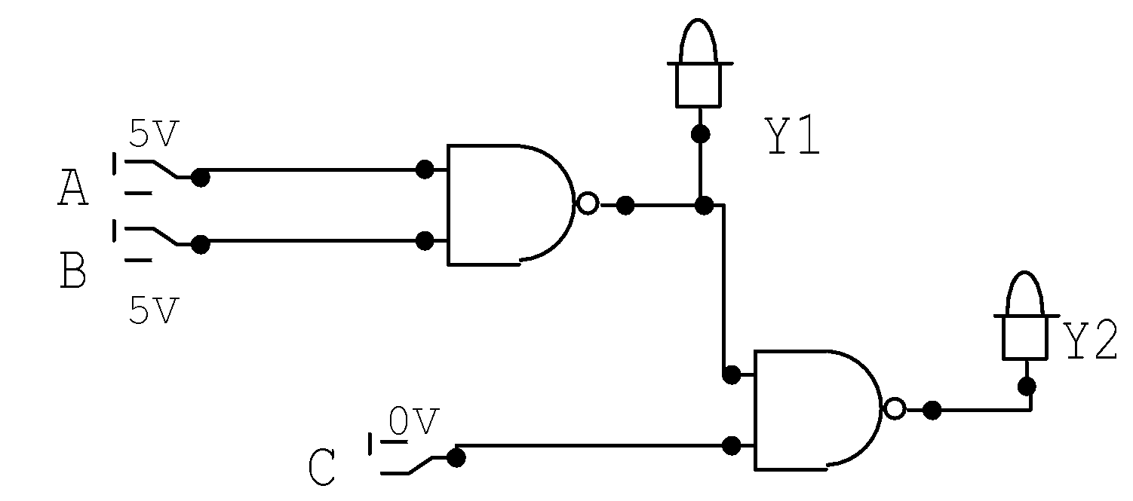

|  |  |  |  |  |
| --- | --- | --- | --- | --- |
| **Inputs** | | | **Output** | |
| A | B | C | Y1 | Y2 |

1. Create and fill the table for Y1.

|  |  |  |
| --- | --- | --- |
| A | B | Y1 |
| 0 | 0 | 1 |
| 0 | 1 | 1 |
| 1 | 0 | 1 |
| 1 | 1 | 0 |

1. Write the operation (Boolean expression) that is performed by circuit to generate Y1.

**Y1=A.B’(NAND)**

1. Implement the above gate on Circuit Maker and verify your results.

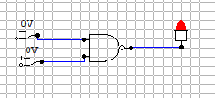

**Part.2** For part 2, consider Y1 and C as input for Y2.

1. Create and fill the table for Y2

|  |  |  |
| --- | --- | --- |
| Y1 | C | Y2 |
| 0 | 0 | 1 |
| 0 | 1 | 1 |
| 1 | 0 | 1 |
| 1 | 1 | 0 |

1. Write the operation that is performed by circuit to generate Y2
2. Implement the above gate on Circuit Maker and verify your results
3. 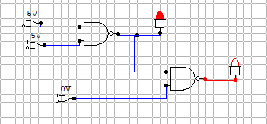

**Part.3** For part 3, consider A, B and C as inputs

1. Create and fill the table for output Y2
2. Write the operation that is performed by circuit to generate Y2
3. Implement the above gate on Circuit Maker and verify your results

**Task 3: The task contains 2 parts.**

1. Consider the given circuitfor part 1

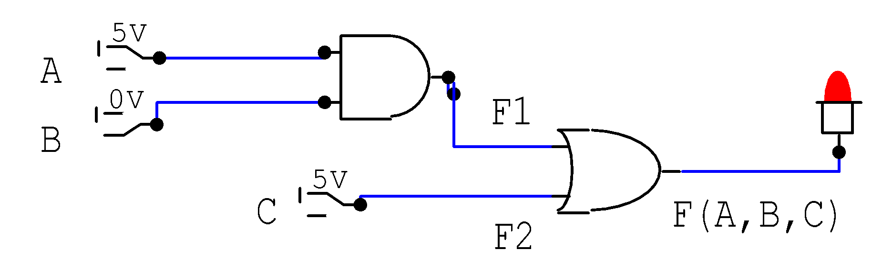

1. Create and fill the table for Y1

|  |  |  |  |  |
| --- | --- | --- | --- | --- |
| A | B | C | A+B | (A+B).C |
| 0 | 0 | 0 | 0 | 0 |
| 0 | 0 | 1 | 0 | 1 |
| 0 | 1 | 0 | 0 | 0 |
| 0 | 1 | 1 | 0 | 1 |
| 1 | 0 | 0 | 0 | 0 |
| 1 | 0 | 1 | 0 | 1 |
| 1 | 1 | 0 | 1 | 1 |
| 1 | 1 | 1 | 1 | 1 |

1. Write the operation that is performed by circuit to generate Y1

**(A+B).C**

1. Implement the above gate on Circuit Maker and verify your results
2. Consider inputs and output given in the above circuit
3. Create and fill the table for output Y2

|  |  |  |
| --- | --- | --- |
| A | B | A.B |
| 0 | 0 | 0 |
| 0 | 1 | 0 |
| 1 | 0 | 0 |
| 1 | 1 | 1 |

1. Write the operation that is performed by circuit to generate Y2

**F1=A.B**

1. Implement the above gate on Circuit Maker and verify your results

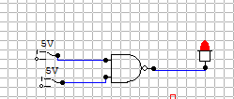

**Task 4: Consider the given circuit**

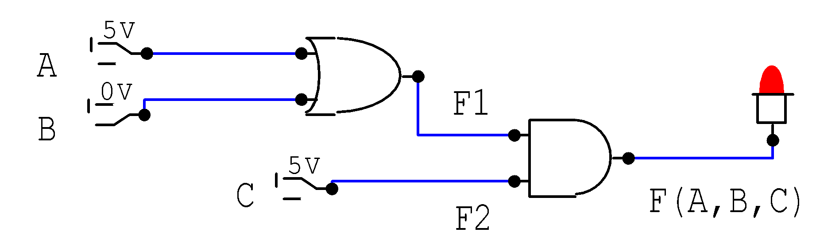

|  |  |  |  |  |
| --- | --- | --- | --- | --- |
| A | B | C | A.B | (A.B)+C |
| 0 | 0 | 0 | 0 | 0 |
| 0 | 0 | 1 | 0 | 1 |
| 0 | 1 | 0 | 0 | 0 |
| 0 | 1 | 1 | 0 | 1 |
| 1 | 0 | 0 | 0 | 0 |
| 1 | 0 | 1 | 0 | 1 |
| 1 | 1 | 0 | 1 | 1 |
| 1 | 1 | 1 | 1 | 1 |

1. Create and fill the table for output Y2

|  |  |  |
| --- | --- | --- |
| A.B | C | F |
| 0 | 0 | 0 |
| 0 | 1 | 1 |
| 1 | 0 | 1 |
| 1 | 1 | 1 |

1. Write the operation that is performed by circuit to generate Y2

**F=(A.B)+C**

1. Implement the above gate on Circuit Maker and verify your results

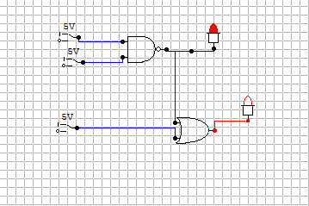

**Lab Task 5:**

1. Draw the circuit for the operation given below(Both are the same equation. Consider only one understandable for you.)
$Y=\left(A NAND B\right) AND (A OR B)$

2. Create and fill the table for output Y

|  |  |  |  |
| --- | --- | --- | --- |
| A | B | A. B | A NAND B |
| 0 | 0 | 0 | 1 |
| 0 | 1 | 1 | 0 |
| 1 | 0 | 1 | 0 |
| 1 | 1 | 1 | 0 |

1. Implement the above gate on Circuit Maker and verify your results

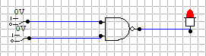

**Task 6: The task contains 2 parts.**

1. Draw the circuit for the following statement.

We have to control an LED with the help of two switches X and Y. However, there are some conditions as mentioned below;

* LED will be only switched on if both the switches X and Y are OFF
* LED will be ON, otherwise

1. Draw the circuit for the following statement.

We have to control an LED with the help of two switches X and Y. However, there are some conditions as mentioned below;

* LED will be switched on if any of the switches X and Y is ON.
* LED will be OFF, otherwise